OpenEx Build Guide/ Instructions

OpenEx was an idea that came to me while searching around for various types of trackballs one evening. I saw of course the Kensington Expert and was immediately inspired to create a trackball device that was emulative of what I had discovered. Currently the wiring for all the switches and other components to the microcontroller is all done by hand with solid core copper wire 22ga; but in the next revision I plan on designing the PCB with sensor circuit integrated as well.

Speaking of the sensor, the one that is currently being used is the sensor from BastardKbs Charybdis keyboard project with the pmw3360 and I plan on trying to make my own sensor design for the next revision as well. <https://github.com/Bastardkb/Charybdis>

For the 3D printed parts I use an Ender3 V1 and it has been very reliable for the hobbyist level. I print with .3mm layers at an extra fast speed and with PLA material.A picture containing text, indoor
(Figure 1. Base, switch positioning and wiring explanation for ProMicro)

Position the switches so the pins are the closest to the opening of the switch slot, make sure the wires and diodes are securely soldered before inserting and then gluing into place with hot glue in the two specified spots in yellow in Figure 1. Cut yourself enough wire so that you can connect all the rows and columns to the microcontroller, these are terms relevant to keyboard matrix creation which is the style of firmware this interface device uses. The USB cord is routed through and secured with hot glue. The pro micro is secured with hot glue as well if you choose, I suggest going light with the hot glue at first and only adding a nickel sized dollop at a time.

(Figure 2. Sensor and encoder wiring and bearing explanation)

The sensor has 6 wires coming off and you will want to pull up a pinout diagram of the promicro and match the coresponding pins from the sensor and the promicro together. For this part I used 6 wire flex cable since it was convenient, on hand, and allowed me to not use as much solid core wire in the build since there was already so much. I also put a dollop of hot glue on the cable after soldering to help strengthen the connection and keep the cable from being pulled out.

The bearings used for this mount are 10mm in diameter and use M5 sized screws to secure them.

There are 3 pins that come off of one side of the encoder and there is a slot in the top shell for them to line up with after soldering a length of solid core wire to connect to the microcontroller. This is another spot that I put a small amount of hot glue on to strengthen the solder joints, ensuring the wires arent pulled off.

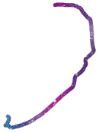

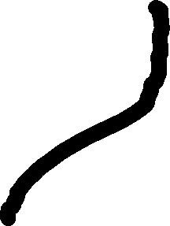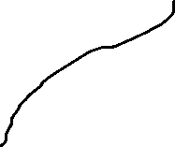

(Figure 3. Overview wiring diagram

My apologies for the rough diagram for the wiring, I am still looking for a good software to draw these kinds of diagrams neater. The way the matrix is setup is as if there is one row and four columns, with the 6 wires from the sensor wrapping around the shell with the other wires from the switches.

The USB cable is positioned in after the sensor and all the switches and encoder is wired in and then hot glued into place, so it isn’t yanked out later in use.

After all components are wired and secured in place, the top and bottom shell are welded together with a soldering iron at 3-4 convenient corners on the outside where they can be not seen as easily

(Figure 4. Overview of all printed components)

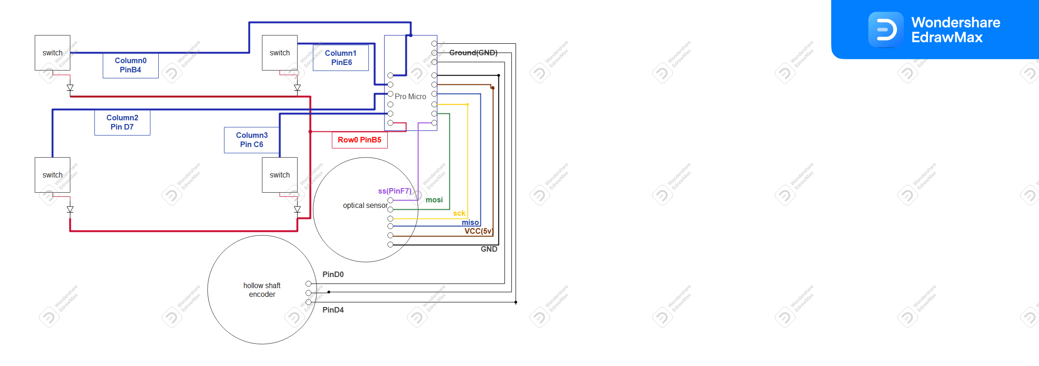

**Bill of Materials**

-Sensor is PMW3360 found on aliexpress

-PCB for sensor found here: <https://github.com/Bastardkb/charybdis-pmw-3360-sensor-pcb>

List of materials for pcb for sensor are found in the same link.

-Hollow shaft encoder

<https://www.mouser.com/ProductDetail/652-PER561P115N0015>

-X3 Bearings 10x4x5

<https://www.amazon.com/gp/product/B00ZVF8OHK/ref=ox_sc_act_title_5?smid=A2M9H7NY6J5VFH&psc=1>

-X3 M5 screws

-22ga solid core wire

-Use MX style keyboard switches

-Use regular ProMicro

